How to Be the Boss of Your AI Assistant

Understanding LLMs & The Research Workflow

Michael Borck

# Welcome!

## Today’s Journey

* Understanding your AI assistant
* Why structure beats magic
* A proven 10-step research workflow
* Live demonstration
* **Your roadmap to AI-powered research**

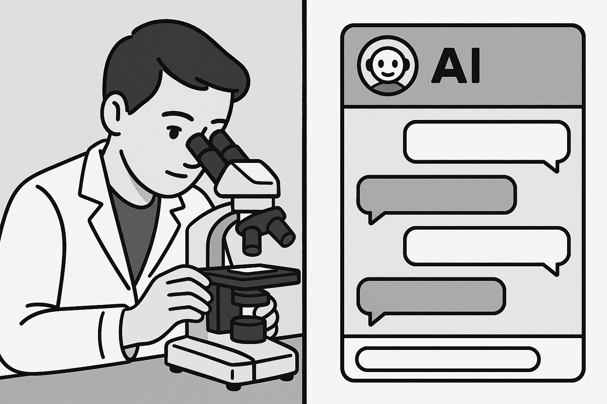

Welcome students. Today we’re learning how to effectively manage AI tools for research. This isn’t about fancy prompts - it’s about understanding how these tools work.

# Acknowledgements

* This presentation has evolved over several iterations since 2022
* Recent updates (2025) were developed with assistance from Claude AI, ChatGPT, Perplexity AI and other tools
* All content has been reviewed, edited, and approved by the presenter
* The integration of AI tools in developing this material reflects the same principles taught within the workshop

# AI’s Relevance to Food Science

* Accelerating literature reviews
* Analysing complex datasets
* Identifying patterns in sensory evaluation
* Predicting food shelf-life and stability
* Enhancing food safety monitoring

AI is increasingly relevant to food science, offering powerful tools for research, data analysis, and optimisation. Machine learning algorithms can uncover patterns and insights in vast food science datasets, while computer vision enables automated quality control and grading of food products. Natural language processing can extract valuable information from research papers and patents to accelerate discovery.

Moreover, AI systems can aid in developing new food products, optimising recipes, and predicting shelf life. They can model complex food systems, simulate processing conditions, and suggest ingredient substitutions. AI also has applications in food safety, such as predicting microbial growth and detecting contaminants. As AI continues to advance, it will likely play an even greater role in driving innovation and efficiency in food science.

# Core AI Concepts for Food Scientists

* No programming knowledge required!
* AI systems learn patterns from large amounts of data
* They generate predictions or responses based on these patterns
* Food science applications span from literature analysis to predictive modelling

Core AI concepts relevant to food scientists include machine learning, deep learning, and natural language processing. Machine learning involves training algorithms on data to make predictions or decisions, which could be applied to food quality control or optimising production processes. Deep learning uses neural networks to analyse complex data like images or sensor readings, potentially automating food safety inspections or creating new product formulations.

Natural language processing enables AI to understand and generate human language, which food scientists could leverage for tasks like analysing consumer feedback or automatically summarising research papers. Other key concepts include computer vision for visual inspection tasks, predictive modelling for forecasting demand or shelf life, and reinforcement learning for optimising control systems. Understanding these core AI techniques equips food scientists to identify high-impact applications in their field.

Here’s an updated **Types of AI** section that combines **practical applications** with the **conceptual classifications** you requested:

# Types of AI

* **Large Language Models (LLMs)** – *Claude, ChatGPT, Gemini, etc.*
* **Data Analysis and Machine Learning Tools** – *Python libraries (scikit-learn, TensorFlow), platforms (RapidMiner, Orange)*
* **Computer Vision / Visual Recognition Systems** – *CNNs, YOLO, OpenCV*
* **Robotics and Autonomous Systems** – *AI-driven machinery, drones, robotic arms*
* **Recommendation and Decision Support Systems** – *Knowledge-based AI, decision trees, expert systems*
* **Speech and Audio AI** – *Speech-to-Text, Text-to-Speech, audio classification*
* **Large Language Models (LLMs)** – *Claude, ChatGPT, Gemini, etc.*
  + Understand and generate human language
  + Summarise research articles, generate research questions
  + Draft experimental protocols and reports
  + Power chatbots and interactive assistants
* **Data Analysis and Machine Learning Tools** – *Python libraries (scikit-learn, TensorFlow), platforms (RapidMiner, Orange)*
  + Perform predictive modeling, clustering, regression, and classification
  + Analyze experimental or production data
  + Build custom AI models for research or industry applications
* **Computer Vision / Visual Recognition Systems** – *CNNs, YOLO, OpenCV*
  + Detect food spoilage or contamination from images
  + Automate quality control in manufacturing
  + Classify products based on visual characteristics
* **Robotics and Autonomous Systems** – *AI-driven machinery, drones, robotic arms*
  + Automate physical tasks (e.g., food packaging, precision agriculture)
  + Use sensor data for navigation and manipulation
* **Recommendation and Decision Support Systems** – *Knowledge-based AI, decision trees, expert systems*
  + Guide ingredient selection or process optimization
  + Suggest experimental designs or production adjustments
* **Speech and Audio AI** – *Speech-to-Text, Text-to-Speech, audio classification*
  + Voice-controlled lab equipment
  + Automated transcription of research interviews
  + Detect anomalies in machinery through sound analysis

# **Conceptual Classifications**

* **Narrow AI (Weak AI)**
* **General AI (Strong AI)**
* **Reactive Machines**
* **Self-Learning (Adaptive AI)**
* **Narrow AI (Weak AI)**
  + Designed for specific tasks (e.g., chatbots, image classifiers)
  + Most AI systems today are narrow AI
  + Cannot perform tasks outside its trained domain
* **General AI (Strong AI)**
  + Hypothetical future AI that can understand, learn, and apply knowledge across multiple domains
  + Would have human-like reasoning and adaptability
  + Does not currently exist
* **Reactive Machines**
  + Respond to inputs with predefined actions
  + No memory or ability to learn from experience
  + Example: Early chess-playing AIs
* **Self-Learning (Adaptive AI)**
  + Learns from data and experience to improve over time
  + Includes machine learning, deep learning, and reinforcement learning systems
  + Example: Modern recommendation engines, autonomous vehicles

# LLMs can help with:

* Summarising key findings from multiple papers
* Extracting methodologies
* Identifying research gaps
* Generating hypotheses
* Proposing experimental designs
* Writing in your academic voice

LLMs are tool that can help food science researchers analyse papers more efficiently. It uses natural language processing to extract key information from research papers, such as the main findings, methodology, and conclusions. This can save researchers significant time and effort when conducting literature reviews or staying up-to-date with the latest research in their field.

To use Research Assistant, researchers simply need to upload a PDF of the paper they want to analyse. The AI will then generate a summary of the paper’s content, highlighting the most important points. Researchers can also ask follow-up questions to delve deeper into specific aspects of the paper. In the live demo, we’ll see how Research Assistant can quickly provide an overview of a food science research paper, making it a valuable tool for any researcher looking to streamline their workflow.

# Understanding LLMs Reliability

* Good at
  + **Average** bad at Precise
  + **Small** bad at Large
* **Hallucinations**: AI can generate plausible but incorrect information
* **Verification strategies**:
  + Cross-check with primary sources
  + Look for citation information
  + Test with known information first
  + Use domain expertise to evaluate outputs

Understanding LLMs reliability is crucial for food scientists leveraging these tools in their research and applications. Key factors to consider include the quality and relevance of the training data, the robustness of the AI model, and its performance on validation and test datasets. It’s also important to assess the model’s ability to generalise to new, unseen data and to handle edge cases and outliers.

Techniques such as cross-validation, error analysis, and sensitivity testing can help gauge an AI model’s reliability. Food scientists should also be aware of potential biases in the data or model and take steps to mitigate them. Collaborating with AI experts, conducting thorough testing, and staying updated on best practices can help ensure the responsible and effective use of AI in food science applications.

# Quick System Check! 📋

**Do you have access to:**

* ✅ Microsoft Copilot (copilot.microsoft.com)
* ✅ Internet connection
* ✅ Ability to download files

**Can’t Access Copilot?**

* Try ChatGPT (chat.openai.com) - free tier works
* Claude (claude.ai) - also free
* **Key point:** The principles work with ANY AI assistant

**Timing:** We’ll have troubleshooting breaks at 15 and 35 minutes!

# The Problem: The “Everything” Prompt

## Have you ever tried this?

* You ask AI to do a huge task all at once…
* “Analyse high-pressure processing for juice shelf life, tell me pros and cons, design an experiment for Vitamin C in orange juice, write the methods, and create expected results table”

# What do you get back? 😕

* ❌ Shallow, generic summary
* ❌ Forgets half your instructions
* ❌ Messy, unusable output

**Real Example:** “Write my entire literature review on plant proteins” → Gets 2 paragraphs of Wikipedia-level content

This happens because you’re giving the AI too much to think about at once. It’s like asking someone to juggle while solving math problems.

# The Solution: Think Like a Manager 🎯

## Not a Magician! ✨

**Big Idea:** Break complex research into small, logical steps

## The Golden Rule - **One Task, One Prompt**

Give your AI assistant one clear job at a time

**Let’s explore why this simple rule is so powerful…**

# Quick Start Essentials 📸

**The Most Important Prompt Template:**

You are an AI research scientist specializing in [YOUR FIELD].  
  
Task: [ONE SPECIFIC TASK]  
  
Requirements:  
- [SPECIFIC REQUIREMENT 1]  
- [SPECIFIC REQUIREMENT 2]  
- [SPECIFIC REQUIREMENT 3]  
  
Format: [HOW YOU WANT THE OUTPUT]  
  
Context: [BACKGROUND INFO IF NEEDED]

**Save this!** 80% of your AI interactions will use this basic structure

# Reason 1: Limited “Working Memory” 🧠

### ❌ The “Everything” Prompt

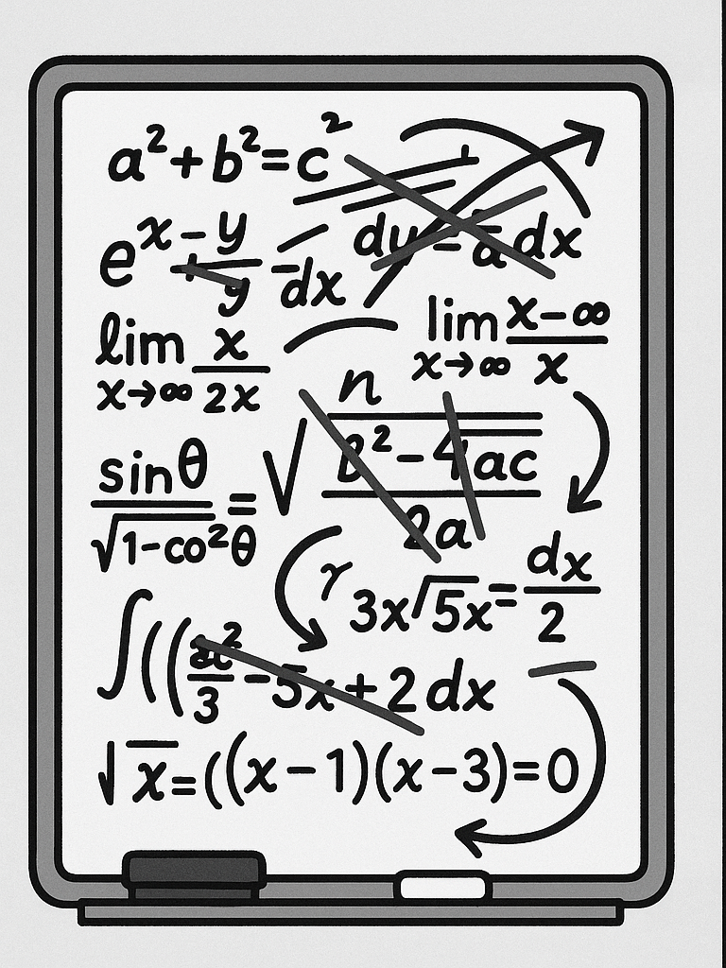 Scribbling 10 problems at once = No room for solutions

### ✅ The Step-by-Step Approach

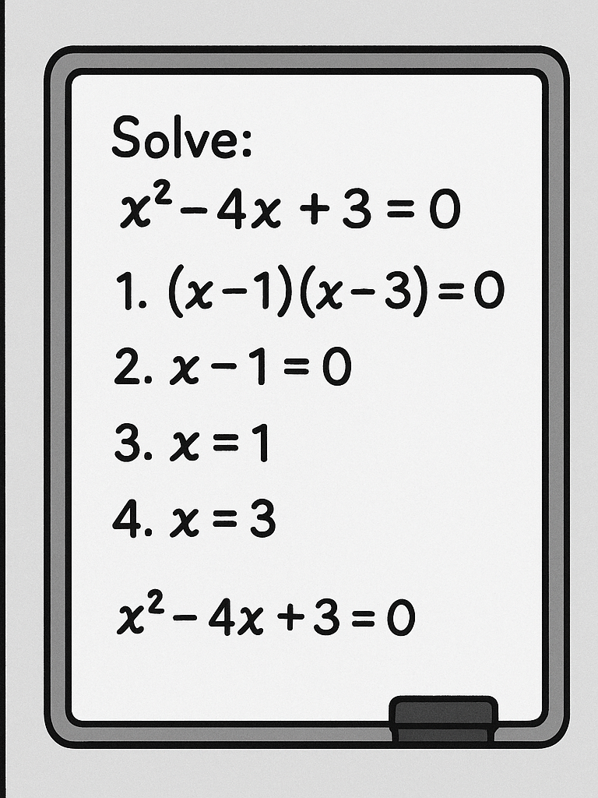 One problem, full space = Detailed, accurate results

**Takeaway:** A single, focused task gets the AI’s full attention

LLMs have a context window - think of it as their working memory. When you fill it with multiple complex tasks, each gets less attention and processing power.

# Technical Detail: Context Windows 📊

## What’s really happening?

* LLMs have **finite context windows** (8k-200k tokens)
* Token ≈ 0.75 words
* Each task competes for this limited space

## Example:

* LLM Context window: ~8,000 tokens
* Complex research prompt: ~500 tokens
* Response space needed: ~1,500 tokens per task
* **Result:** Only 3-4 tasks fit properly!

**Think of it like RAM:** Too many programs = computer slows down. Too many tasks = AI quality drops.

This is why breaking tasks down isn’t just helpful - it’s technically necessary for quality outputs.

# Reason 2: Guiding the AI’s “Thinking” 🧭

## LLMs Create Answers Piece by Piece

* Each word depends on previous words
* Complex prompts = mental shortcuts
* Structured prompts = logical reasoning

## Cooking Analogy 👨‍🍳

**❌ Bad:** “Make beef wellington”

*Chef might skip steps or use wrong ingredients*

**✅ Good:** 1. “First, sear the beef” 2. “Next, prepare duxelles” 3. “Then, wrap in pastry”

By giving step-by-step instructions, you force the AI to build a logical argument, leading to much stronger outputs.

# Reason 3: Easy Error Detection & Fixing 🔧

### With a Giant Prompt

* Problem: Weak experimental method
* Solution: Re-run EVERYTHING
* Time lost: 10-15 minutes
* Quality: Hope for the best 🤞

### With Our Workflow

* Problem: Weak experimental method
* Solution: Fix just that step
* Time lost: 2 minutes
* Quality: Keep what works ✓

**Benefit:** Iterative refinement = Higher quality + Less frustration

# Reason 4: More and Better Ideas 💡

## Diversity vs. Convergence

### ❌ Single Prompt Approach

“Give me the best hypothesis for oat milk fermentation” → **One idea, possibly mediocre**

### ✅ Our Multi-Step Approach

1. **Generate:** “Give me 5 hypotheses” → **Diversity**
2. **Evaluate:** “Score each for feasibility” → **Analysis**
3. **Select:** “Recommend the top 3” → **Quality**

**Result:** Multiple perspectives + Critical evaluation = Stronger research

# Good AI Outputs Look Like This:

**✅ Structure & Detail** - Organized sections - Specific numbers/examples - Academic language - Proper formatting

**✅ Actionable Content** - Clear next steps - Testable hypotheses - Realistic timelines - Measurable outcomes

# Bad AI Outputs Look Like This:

**❌ Vague & Generic** - “Consider various factors…” - “This is an important topic…” - “Results may vary…”

**❌ Incomplete** - Missing key sections - No specific examples - Unclear methodology

# The 10-Step Research Workflow 🔬

*From Idea to Manuscript*

**Discovery Phase (Steps 1-5)** ⏱️ *~60 minutes* 1. **Idea Generation** - Brainstorm hypotheses *(8 min)* 2. **Parallel Exploration** - Diversify ideas *(12 min)* 3. **Preliminary Testing** - Feasibility checks *(10 min)* 4. **Optimization** - Find best parameters *(15 min)* 5. **Full Execution** - Main study design *(15 min)*

# The 10-Step Research Workflow (cont’d) 📝

*From Idea to Manuscript*

**Communication Phase (Steps 6-10)** ⏱️ *~40 minutes*

1. **Component Analysis** - What matters most? *(8 min)*
2. **Visualization** - Create figures & charts *(10 min)*
3. **Writing** - Draft manuscript *(12 min)*
4. **Review** - Peer review simulation *(5 min)*
5. **Iteration** - Continuous improvement *(5 min)*

**Total time:** ~100 minutes for a complete research project from idea to first draft!

This mirrors the **actual scientific method** - we’re just using AI as our assistant!

# Step 1: Idea Generation 🌱

## The Power of Structured Brainstorming

**Prompt Template:**

You are an AI research scientist specializing in Food Science.  
Given the following research area, generate 5 distinct and   
innovative scientific hypotheses suitable for a Masters-level   
research paper.  
  
For each hypothesis, include:  
- A clear Title  
- 3-5 Keywords  
- A short Abstract (under 200 words)  
- An explanation of its Novelty and Significance  
  
Research Area: [YOUR TOPIC HERE]

**Pro tip:** Replace “Food Science” with your specific field for better results!

Notice how specific this prompt is. We’re not just asking for “ideas” - we’re asking for structured, academic hypotheses.

# Step 2-3: Exploration & Feasibility 🔍

## Step 2: Parallel Exploration *(12 min)*

* Open multiple chat sessions
* Generate non-overlapping ideas
* Score and rank all options
* **Output:** 10-15 diverse hypotheses

## Step 3: Preliminary Testing *(10 min)*

* Select top hypothesis
* Design minimal experiment
* Generate expected data
* **Output:** Feasibility confirmed

**Key insight:** Step 2 prevents tunnel vision - you see ALL possibilities before committing!

# Steps 4-6: The Research Core 🔬

## Building Your Study

**Step 4: Optimization** *(15 min)* - Test variable combinations - Define success criteria - Find the “sweet spot”

**Step 5: Full Execution** *(15 min)* - Detailed methodology - Comprehensive data tables - Statistical measures

**Step 6: Component Analysis** *(8 min)* - What ingredients matter? - Ablation studies - Understanding mechanisms

# Steps 7-10: Communication & Refinement 📊

**Step 7: Visualization** *(10 min)* - Generate scientific figures - Write clear captions - Visual storytelling

**Step 8: Manuscript Writing** *(12 min)* - Complete paper draft - All sections included - Proper citations

**Step 9: Peer Review** *(5 min)* - Critical evaluation - Scoring rubric - Actionable feedback

**Step 10: Iteration** *(5 min)* - Address weaknesses - Refine sections - Achieve excellence

# When AI Goes Wrong: Real Examples 🚨

## Hallucination Alert!

**Made-up Citations:** > “According to Smith et al. (2023), fermentation at 45°C increases yield by 23%”

**Reality:** Paper doesn’t exist!

**Plausible but Wrong Data:** > “Oat milk contains 15g protein per 100ml”

**Reality:** Usually 1-3g per 100ml

# What You Should Do:

1. **Always verify** numerical claims
2. **Check citations** before using them
3. **Cross-reference** with reliable sources
4. **Use AI for structure**, not facts

**Remember:** AI is confident even when wrong!

# Ethical Guidelines: Using AI in Academic Work 📜

## The Right Way to Cite AI Assistance

**In your methods section:** > “Hypothesis generation and experimental design were developed with assistance from Microsoft Copilot (Microsoft Corporation, 2024). All outputs were verified against peer-reviewed literature.”

## What Requires Citation:

* ✅ Idea generation
* ✅ Statistical analysis suggestions
* ✅ Writing structure
* ✅ Data interpretation ideas

## What Doesn’t:

* Grammar checking
* Simple calculations
* Basic formatting

**Bottom line:** When in doubt, cite it. Transparency builds trust.

# AI Deep Research: OpenAI vs Perplexity vs Open Source

| Criteria | Perplexity Deep Research | OpenAI Deep Research | Open Source Alternative (AgentGPT) |
| --- | --- | --- | --- |
| **Speed** | Fast (Reports in < 3 mins) | Moderate (Reports in 5–30 mins) | Moderate-Fast (Varies by hardware/setup) |
| **Cost** | Free (5 queries/day)$20/mo (500/day) | $200/mo (100 queries) | Free (Open Source, self-hosted) |
| **Accuracy (Benchmark)** | Moderate (20–21%) | High (26.6%) | Variable (Depends on model & tuning) |
| **Report Quality** | Good but occasional factual inaccuracies | Excellent, structured, comprehensive citations | Variable, highly customizable |
| **Best For** | Quick, accessible research with budget constraints | In-depth, accurate, professional/academic research | Customizable solutions, DIY research environments |

**Summary:** - **Perplexity:** Ideal for fast, affordable reports; some inaccuracies possible. - **OpenAI:** Best for detailed, accurate, structured research with citations. - **Open Source (AgentGPT):** Flexible, cost-effective, customizable, but requires setup and tuning.

When comparing AI research tools, Perplexity is best for fast, affordable reports, but may have some inaccuracies. OpenAI excels at detailed, accurate, structured research with citations. Open source options like AgentGPT are flexible, cost-effective, and customisable, but require setup and tuning.

Each tool has strengths and weaknesses depending on the research needs. For quick, budget-friendly reports, Perplexity is a good choice, keeping in mind minor inaccuracies are possible. For thorough, precise research with proper citations, OpenAI is the top pick. Open source AI like AgentGPT offers flexibility and affordability, but demands more technical setup and fine-tuning to achieve optimal results.

# NotebookLM: Your Personal Research Assistant

**NotebookLM** is an AI-powered tool from Google designed to help you understand and make connections within your own documents. Think of it as a virtual research assistant that only uses the sources you provide.

# How it Works (Simply)

It’s like having a conversation with your course materials:

1. **Upload Your Sources:** Add your PDFs, lecture notes, articles, or Google Docs into a “notebook.”
2. **Ask Questions:** Ask questions in plain language, just like you would ask a tutor. For example, “What are the main arguments in this paper?” or “Compare the theories from these two lectures.”
3. **Get Grounded Answers:** NotebookLM provides answers and creates summaries based *only* on the documents you uploaded. Crucially, it provides citations, showing you exactly where it found the information in your sources.

# Why Use It for Study & Research?

* **Understand Complex Topics:** Get clear explanations of difficult concepts from your readings.
* **Summarize & Synthesize:** Quickly generate summaries of long documents or combine ideas from multiple sources.
* **Brainstorm & Outline:** Ask it to generate ideas, create study guides, or draft outlines based on your material.
* **Fact-Checking:** Easily verify information and find supporting evidence within your trusted documents.

# Live Demo Time! 🚀

## Your Choice: Which Research Should We Explore?

**Option A: 🥛 Fermentation Study** - Oat milk fermentation - pH, cell counts, viscosity - 3 treatments over 48 hours

**Option B: 📅 Shelf Life Analysis** - Yogurt alternatives - Microbial & sensory data - 4 products over 30 days

**Option C: 👅 Sensory Panel** - Plant-based cheese - 50 panelists - Texture, flavor, preference

**Option D: 🧪 Process Optimization** - Protein extraction yields - Temperature vs pH effects - Response surface data

# 🗳️ Vote Now!

Scan QR code



# Quick Demo: Bad vs. Good Prompting 🎯

## Let’s try both approaches… *(10 minutes total)*

### First: The “Everything” Prompt *(3 min)*

*Watch what happens when we ask for too much at once*

“Analyze [winning dataset], create graphs, write conclusions, and suggest future research”

### Then: Our Structured Approach *(7 min)*

*See the difference when we break it down*

Steps 1 → 3 → 7 in sequence

**Pay attention to:** Response quality, detail level, and actionability

# Troubleshooting Common Issues 🔧

## When Things Don’t Work

**Problem:** AI gives generic responses - **Solution:** Add more specific requirements to your prompt

**Problem:** Getting confused by long conversations - **Solution:** Start a new chat session

**Problem:** AI refuses to help - **Solution:** Rephrase more academically, avoid trigger words

**Universal fix:** When stuck, start fresh with a clearer, more specific prompt

# Understanding AI Limitations ⚠️

## Critical Things to Know

**Hallucinations** - AI can “make up” information - Fake citations are common - Always verify sources - May invent plausible-sounding data

**Other Limitations** - Knowledge cutoff dates - Can’t access real databases - No actual lab work - Context window limits

# Golden Rule for Research

**Never trust, always verify!** Use AI for ideation and structure, but validate all facts, citations, and data.

# Key Takeaways 🎓

1. **One Task, One Prompt** - Your golden rule
2. **Structure = Success** - Guide the AI step-by-step
3. **Iterate & Refine** - Fix what needs fixing
4. **Think Like a Manager** - You’re the boss!
5. **Always Verify** - AI assists, you validate

## Next Session Preview 👀

* Hands-on practice with all 10 steps
* Building your own AI research agent
* Advanced techniques and shortcuts
* **Bring a research topic you’re curious about!**

# Your Mission (Should You Choose to Accept) 🎯

## Before Next Session:

1. **Think** of a research topic you’re interested in
2. **Try** the idea generation prompt on your own
3. **Note** what works and what doesn’t
4. **Bookmark** copilot.microsoft.com or your preferred AI tool

# Remember

You’re not learning to use AI - you’re learning to **manage** AI

# Questions? 🤔

## Let’s Discuss!

* Concerns about the workflow?
* Technical questions?
* Want to see another demo?
* Ethical considerations?



## 📧 Contact: michael.borck@curtin.edu.au

# Bonus Slide: The Complete Workflow 📋

## Your Research Assistant Checklist

| Step | Task | Time | Output |
| --- | --- | --- | --- |
| 1 | Idea Generation | 8 min | 5 hypotheses table |
| 2 | Parallel Exploration | 12 min | 10-15 total ideas |
| 3 | Feasibility Testing | 10 min | Experimental plan + data |
| 4 | Optimization | 15 min | Best parameters |
| 5 | Full Study | 15 min | Complete methodology |
| 6 | Component Analysis | 8 min | Key factors identified |
| 7 | Visualization | 10 min | Figures + captions |
| 8 | Writing | 12 min | Full paper draft |
| 9 | Review | 5 min | Feedback report |
| 10 | Iteration | 5 min | Refined manuscript |

This is a reference slide students can photograph or refer back to.

# Resources & Links 📚

## Everything You Need

* **Presentation slides:**
* **All datasets:**
* **Audio version:**
* **Video explainer:**
* **Quick reference:**



**Created with assistance from Claude (Anthropic)**